Scale invariant feature transform

Harris corner detection is rotation invariant, but not scale invariant

Differences of Gaussian smoothing are found at different scales to find local extrema

Weak key points and weak edges are discarded using thresholding and other measures

Orientation is assigned to each key point using a neighborhood and magnitude and direction of gradient. Histogram is created with 36 bins of 10 degrees from 0 through 360 degrees, highest peak and any above 80% are taken and more keypoints are created in those regions

Keypoint descriptor is created around each keypoint, another neighborhood, 16 by 16 with an 8 bin orientation histogram for each of the 16 blocks

Keypoints are matched by identifying nearest neighbors, using the ratio of closest to second closest and comparing to a threshold( usually greater than .8 ) than they are too similar and rejected, this rejects 90% of false matches and only 5% of correct matches

That was a brief summary of the key ideas i was able to understand with my limited knowledge of multivariable calculus and linear algebra

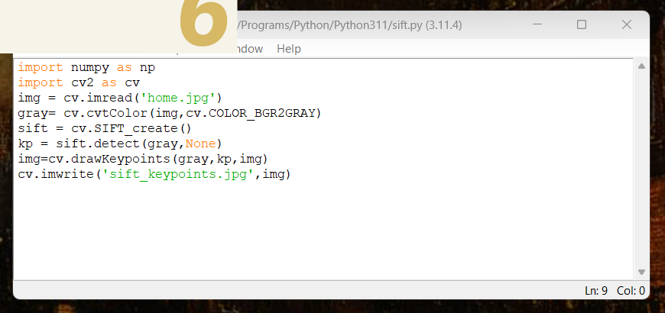

Code uses cv.SIFT_create()

sift.detect()

And .drawKeypoints()



Results



Flags to draw keypoints with orientation

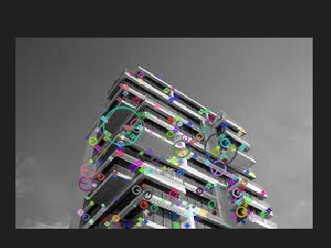

Probably should have used a larger image but the feature orientations are included